**DREAM 11**

**SITE AUDIT**

**On page SEO**

1. **Title Tag**

Dream 11 have a title tag of optimal length (between 10 and 70 characters).  
(Play Fantasy Sports & Win Cash Prizes on Dream11 App | Dream11)  
Length: 66

The title tag is an HTML code tag that allows you to give a web page a title

1. **Meta Description Tag**

The page has a meta description tag however, your meta description should ideally be between 70 and 160 characters (including spaces).

(Play Fantasy sports games with over 15 crore users. Download the Dream11 app and win cash prizes. Earn up to ₹500 cash bonus! Dream big with Dream11. Select a Match > Create a Fantasy Team > Join Contests)

Length: 204

A meta description tag generally informs and interests users with a short, relevant summary of what a particular page is about.

1. **Language**

The page is using the lang attribute.

Builds up a set of HTML attributes containing the text direction and language information for the page.

1. **H1 Header Tag Usage**

The page has a H1 Tag.

An H1 tag is an HTML heading used to mark up a webpage’s main subject.

1. **Keyword Consistency**

Dream11 page's main keywords are distributed well across the important HTML tags.

Individual Keywords

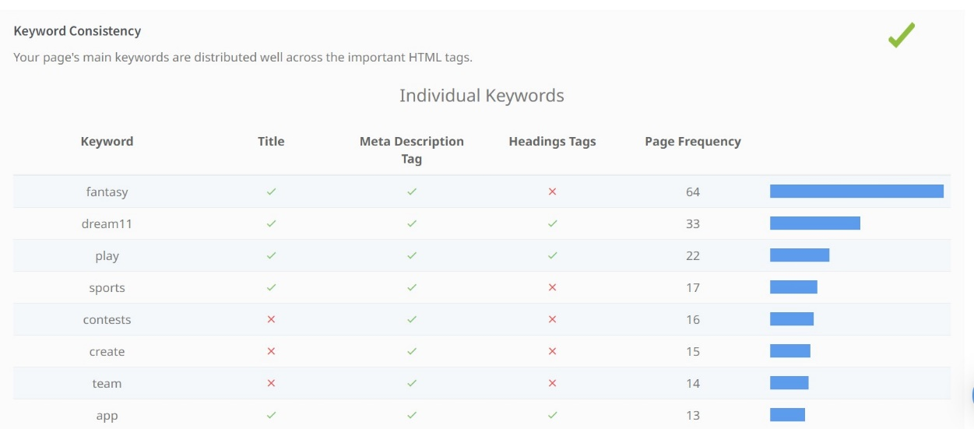

1. **Amount of Content**

This page has a good level of textual content, which will assist in its ranking potential.

1. Word Count: 1405
2. **Image Alt Attributes**

This have images on the page that are missing Alt attributes.

We found 54 images on your page and 11 of them are missing the attribute.

Alt attributes are an often overlooked and simple way to signal to Search Engines what an image is about, and help it rank in image search results.

1. **Canonical Tag**

This page is using the Canonical Tag

**Technical SEO**

* + - 1. **No index Tag Test**

This page is not using the No index Tag which prevents indexing.

used to prevent indexing content by search engines that support the no index rule.

1. **SSL Enabled**

Website has SSL enabled.

SSL (Secure Sockets Layer) is a transaction security standard that provides encrypted protection between browsers and App Servers.

1. **HTTPS Redirect**

Page successfully redirects to a HTTPS (SSL secure) version.

1. **Robots.txt**

Website appears to have a robots.txt file.

1. **XML Sitemaps**

Website appears to have an XML sitemap.

1. **Schema.org Structured Data**

Using JSON-LD Schema on your page.

**Off page SEO**

1. **On-Page Link Structure**

I found 42 total links. 50% of your links are external links and are sending authority to other sites. 2% of your links are no follow links, meaning authority is not being passed to those destination pages

**How to improve?**

* **Meta Description Tag**

Thispage has a meta description tag however, your meta description should ideally be between 70 and 160 characters (including spaces).

Length: 204

* **Image Alt Attributes**

Have images on your page that are missing Alt attributes.

I found 54 images on your page and 11 of them are missing the attribute.

Alt attributes are an often overlooked and simple way to signal to Search Engines what an image is about, and help it rank in image search results.

* **Analytics**

I could not detect an analytics tool installed on your page.

Website analytics tools like Google Analytics assist you in measuring, analysing and ultimately improving traffic to your page.

* **Friendly Links**

Some of the link URLs do not appear friendly to humans or search engines.

We would recommend making URLs as readable as possible by reducing length, file names, code strings and special characters.

* **Legible Font Sizes**

There is some text on your page that is small and may not be legible enough for particular users.

I recommend reviewing all text on your page in different devices to ensure that it is of appropriate size.

* **JavaScript Errors**

Page is reporting JavaScript errors during load.

This could indicate that some required functionality on your page is failing or scripts may have coding problem

* **Usability**

Page is OK but could be more usable across devices.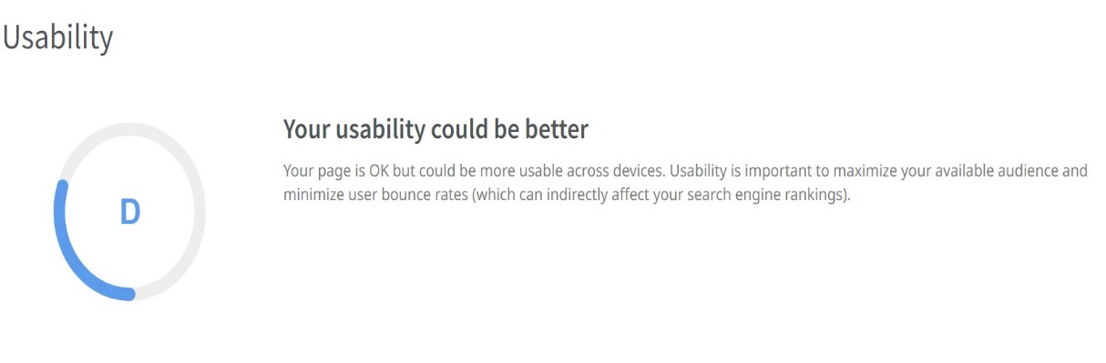

* **Google's Page Speed Insights – Mobile**

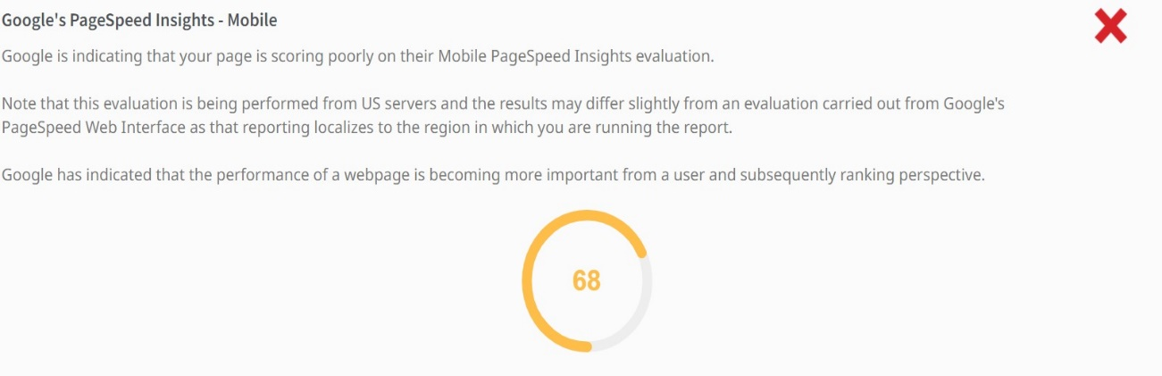

**KEYWORD STRATEGY**

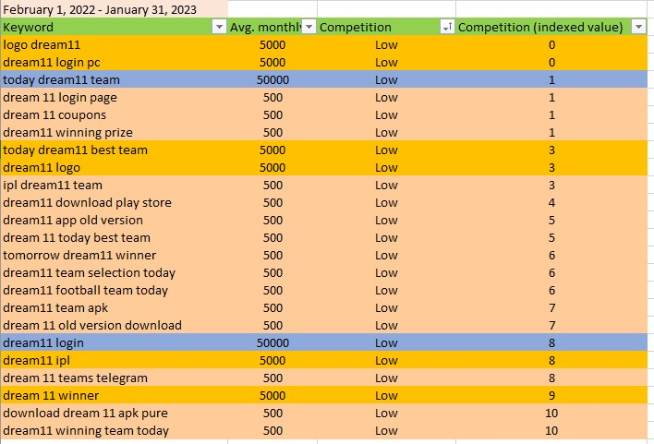

* Using the Keyword Planner in Goggle Ads we have created the keyword strategy for Dream 11.
* With the context of the domain (here Dream 11) we have to do some brainstorming with the related and relevant keywords. And make a list of it. And put some of the keywords in keyword planner tool.
* We get thousands of keywords ideas on these tools. We have to filter some keywords based on competition index value, exclude some of the keywords which are not relevant to our domain.
* Our keywords ideas will get shorten after this procedure. Export these files in csv format and open in excel files.

***So, here we will implement our keyword strategy plan-***

* Low competition keywords- Get emphasised on the low competition keywords. Low competition keywords help to get better ranking in search engine result page with less efforts.
* Average monthly searches (Volume)-Give weightage to the high-volume keywords so that it is easy for us to get rank. More users are going to search on these keywords more chances of getting rank in serp.
* Competition index- I emphasis on getting low competition index value. The value shows how competitive a keyword is for the location and search network you've selected.

**GOOGLE SEARCH AD CAMPAIGN**

* Created the search ad campaign in Google ads. Based on the keyword strategy I try to emphasis on the users who try to log in through the app, who want to know about the good team in dream11. We do this by creating separate ad group.



* Give importance to the audience. Target the audience who are interested in fantasy sport games.

This is the screenshot of targeting the audience according to our domain.

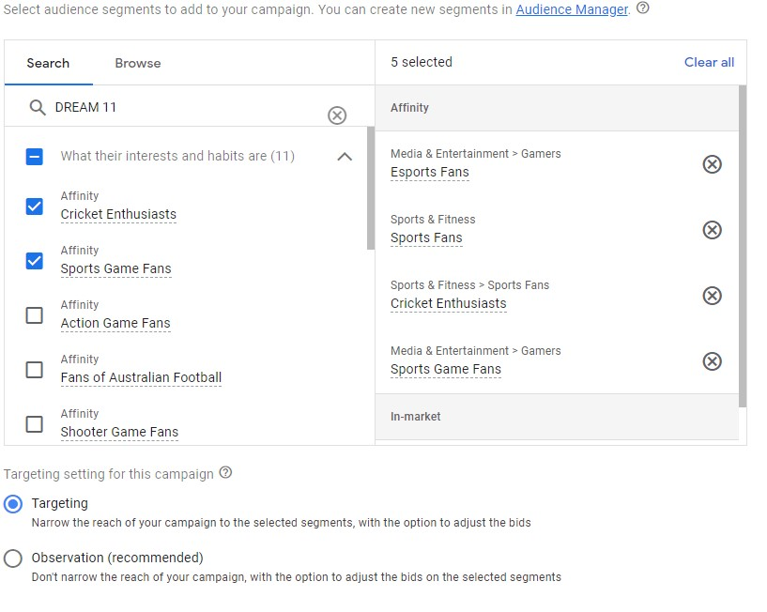

* This is the final template of how our ad will look.

